Relax Data Science Challenge
In this project, we were asked to build a model to predict active users from login data. Active users were defined as anyone who has logged in three times in any 7 day period in the dataset.
After cleaning the data, my approach was to use the takehome_user_engagement.csv data to define the target category. I used the rolling function to create a new column showing the rolling sum of logins over 7 days for each unique user_id. The maximum value of rolling_sum per unique user_id was used to define the user’s status, with anything three or greater being mapped as Active. These values were joined to the users metadata and any users in the metadata but not in the login data were marked as Inactive.
From here, I followed a standard classification machine learning pipeline:
1. Train/test split
2. Standardize numeric columns and One Hot Encode categorical columns
4. Screen Random Forest and XGBoost Classifiers with Cross Validation
5. Hyperparameter Tune Top Classifier
6. Examine Feature Importance

The user data was moderately imbalanced with approximately five times as many Inactive users as Active. I looked at variety of metrics when evaluating these models, including ROC_AUC, accuracy, precision, recall and F1, but found the confusion matrix to be the most informative (Figure 1). XGBoost Classifier performed the best in metrics that accounted for false negatives like F1 and Recall and had a more balanced confusion matrix. The XGBoost Classifier went forward into hyperparameter tuning with a focus on hyperparameters to improve imbalanced data, such as the scale_pos_weight (Figure 2).
As part of the goal of this project was to find the features which were important for predicting active users, I looked at feature importance and SHAP values for the final model (Figure 3). Blue dots on the positive side of the x-axis indicate that low values in that category inform class 1 predictions, while red dots on the right side of the axis mean that high values inform class 1 predictions. From this we can reach a few conclusions about how the data informs model predictions.
1. High numbers in 'last_session_creation_time' indicate uses that are more likely to be active.
2. For creation year, low numbers are associated with active users. These must be users that have been with the company for a long time and are stable customers. Also, they have more time to achieve an active status, which is three logins in 7 days.
3. For creation month and day, low numbers are also associated with active users. The cause here is less clear, but it could be the same trend as seen for year on a smaller scale.
For next steps, I would recommend doing a deeper dive into the login data and doing more feature creation to find out when the users are the most active. This could include looking at weekday vs weekend logins, night vs daytime, or regular vs sporadic users. While this level of analysis was outside the scope of this investigation, it would allow for a more nuanced model.

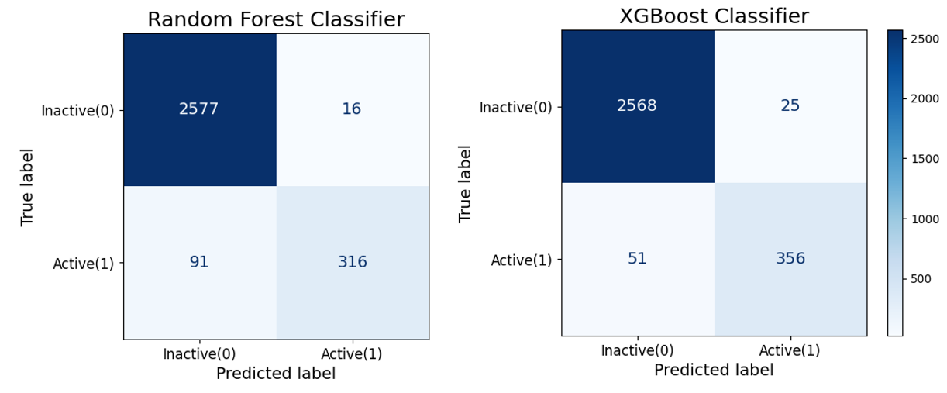
Figure 1: Confusion matrices for Random Forest and XGBoost Classifiers during model screening.

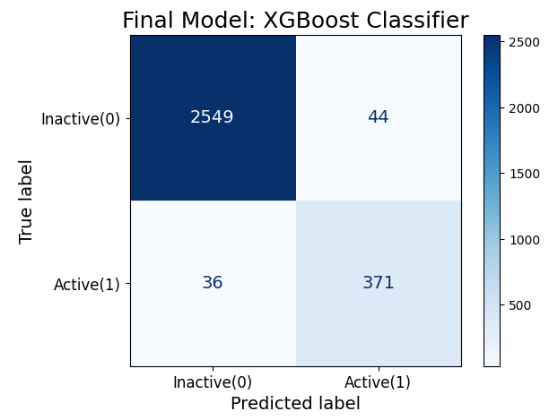
Figure 2: Confusion matrices the final XGBoost model after hyperparameter tuning.

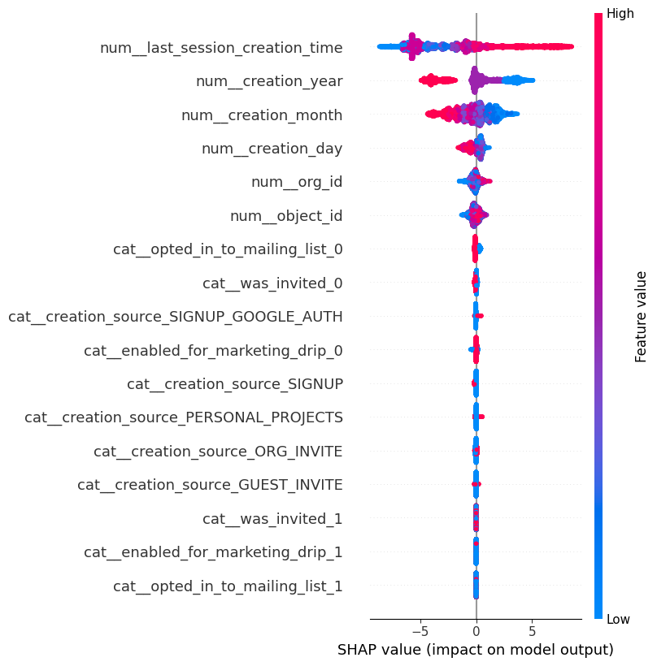
Figure 3: SHAP values describing feature contribution to predictions in the final XGBoost model. A positive SHAP value pushes a prediction towards class 1 (Active) and a negative SHAP value pushes a prediction towards class 0 (Inactive). Red indicates high values, and blue indicates low values, and each dot represents a prediction.

